

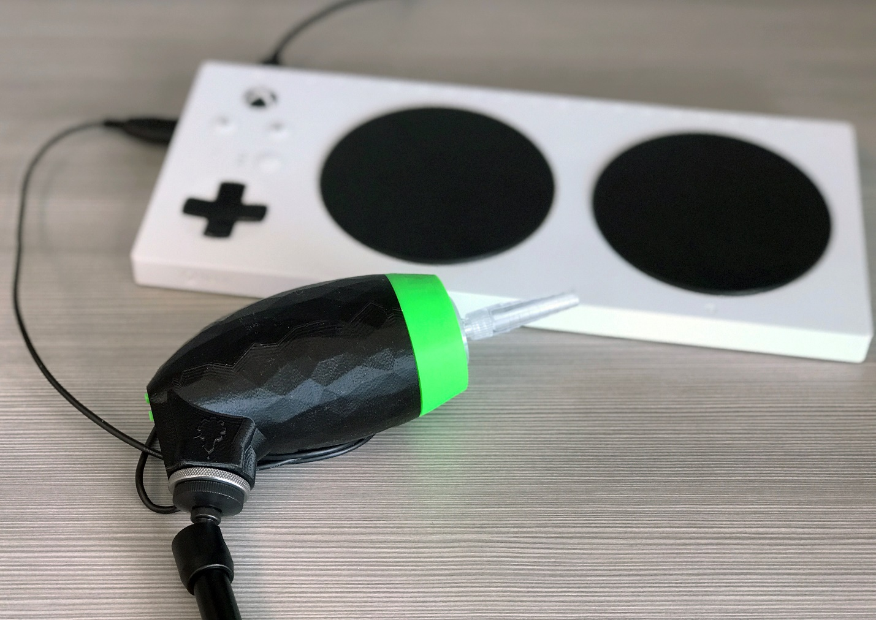

LipSync Gaming

SETUP GUIDE

**Version 1.1 / March 2020**  **www.MakersMakingChange.com**

Table of Contents

About the LipSync Gaming 3

What Do You Get? 3

Types of LipSync 3

Device Compatibility 4

Powering the Controller 4

LipSync Gaming Firmware Installation 5

Setting Up the LipSync Gaming for PC Gaming 6

Functions (PC Games): 6

Setting Up the LipSync Gaming with the Xbox Adaptive Controller 7

Functions (Xbox Adaptive Controller): 7

Customize Profile 8

Cleaning the LipSync 11

References 11



# About the LipSync Gaming

The LipSync Gaming emulates a gaming controller for PC gaming and the XBOX console. Users can move the mouthpiece up, down, left, and right; and use the sip-and-puff for other controller functions. This adaptive gaming device is suitable for users with limited or no hand and finger dexterity. It can be paired with auxiliary controllers, like the XBOX Adaptive Controller, to suit a gamer’s needs.

It is an open source assistive technology design by Makers Making Change, a program of the Neil Squire Society that connects volunteer makers with people with disabilities to create more affordable assistive technology. Join the Makers Makers Making Change to help people in your community: <http://www.makersmakingchange.com>

## What Do You Get?

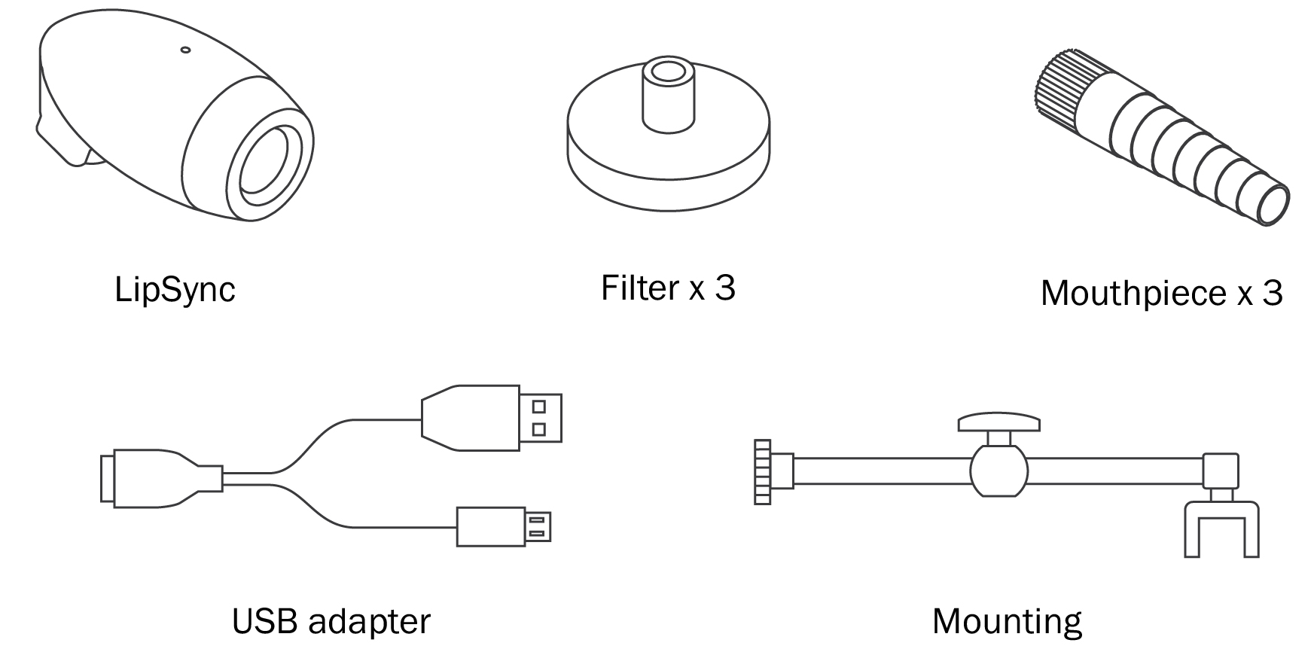

# 

## Types of LipSync

|  |  |  |
| --- | --- | --- |
|  | Description | Connection Type |
| LipSync | Works like a mouse | USB |
| LipSync Wireless | Works like a mouse | USB & wireless |
| LipSync Macro | Works like a keyboard | USB & wireless |
| **LipSync Gaming** | **Works like a gaming joystick** | **USB** |

## Device Compatibility

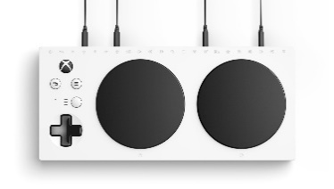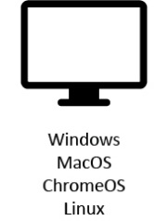

Xbox  
(only with the Xbox   
Adaptive Controller)

Windows  
MacOS

Xbox Adaptive Controller

## Powering the Controller

The Adaptive Controller has an internal rechargeable battery that allows users to use it wirelessly. Using the LipSync (and any external accessibility switch) will draw additional power.

To prevent fast power consumption, we recommend the Adaptive Controller be plugged into to an electrical outlet using an AC Adapter (Option 1) or a power bank of at least 5000mAH (Option 2) using a USB to USB-C cable while gaming.

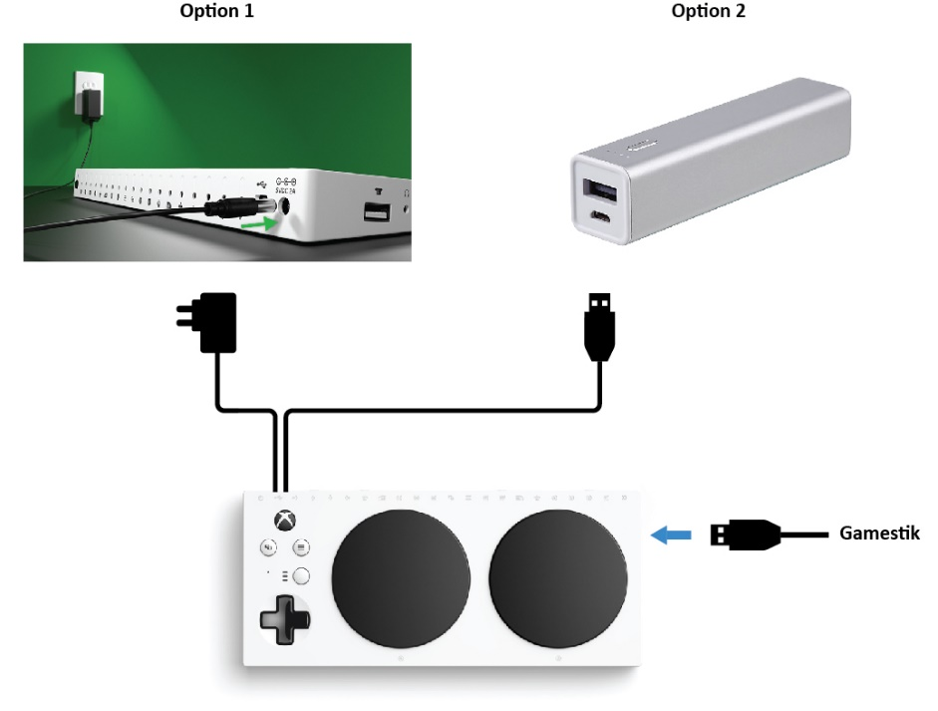

# LipSync Gaming Firmware Installation

1. Download and install the latest version of Arduino IDE from the following link: <https://www.arduino.cc/en/main/software>
2. Download the Gaming firmware from the following link: [https://github.com/makersmakingchange/LipSync-Gaming/raw/master/Software/LipSync_Gaming_Firmware/LipSync_Gaming_Firmware.ino](https://github.com/makersmakingchange/LipSync-Gaming/raw/master/Software/LipSync_Gaming_Firmware/LipSync_Gaming_Firmware.ino%22%3ELipSync_Gaming_Firmware.ino)
3. Visit the ***“ArduinoJoystickLibrary”*** GitHub repository using following link: **[1]** <https://github.com/MHeironimus/ArduinoJoystickLibrary>
4. Download the “***ArduinoJoystickLibrary”*** by clicking on ***"Clone or Download"*** button and then selecting ***"Download ZIP"*** option.
5. Extract the "ArduinoJoystickLibrary-master.zip" file.
6. Copy the Joystick folder to the Arduino libraries folder. An example of path to Arduino libraries folder in Windows: ***"C:\Program Files (x86)\Arduino\libraries"***.
7. Once the folder is copied, the Joystick library should appear in the Arduino IDE list of libraries.
8. Plug the LipSync USB cable into the computer port.
9. Open Arduino IDE and you should be able to see Joystick examples under ***“File>Examples>Joystick”***.
10. Now open the ***“LipSync_Gaming_Firmware.ino”*** file using Arduino IDE.
11. Select the ***“Arduino/Genuino Micro”*** as the Board and then select the available port number under Tools option.
12. Click on upload button to upload the code.  
    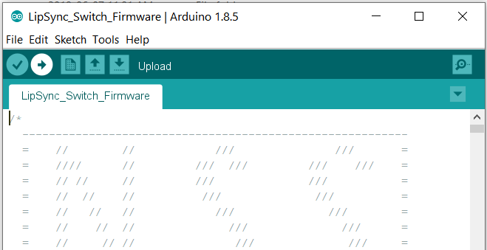

LipSync_Gaming_Firmware

# Setting Up the LipSync Gaming for PC Gaming

1. Plug the LipSync USB to any computer or laptop USB Port. 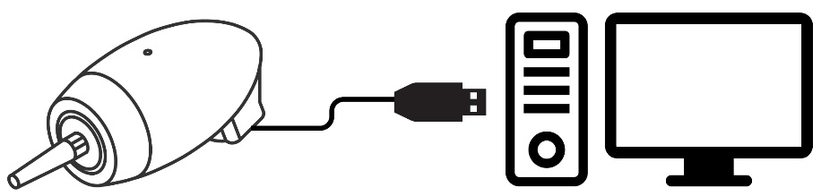
2. Start up the PC game. The LipSync will not behave like a computer mouse outside of the gaming window.
3. Adjust the sensitivity of the sip-and-puff features by pressing the triangular buttons on the back of the LipSync. Increase the sensitivity by pressing the triangular button and decrease it by pressing the triangular button.

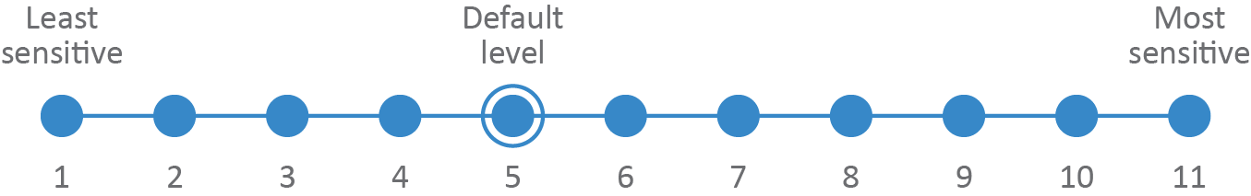

1. If any of the functions starts to drift while you’re playing a game, release the mouthpiece and hold both triangular buttons at the same time to reset.

## Functions (PC Games):

|  |  |  |
| --- | --- | --- |
| LipSync Action | Time (Seconds) | Function |
| Mouthpiece (Right) | N/A | Move right |
| Mouthpiece (Down) | N/A | Move down |
| Mouthpiece (Left) | N/A | Move left |
| Mouthpiece (Up) | N/A | Move up |
| Puff | 1 | Button Number 1 |
| Sip | 1 | Button Number 2 |
| Puff | 2 | Button Number 3 |
| Sip | 2 | Button Number 41 |
| Puff | 3 | Button Number 5 |
| Sip | 3 | Button Number 6 |

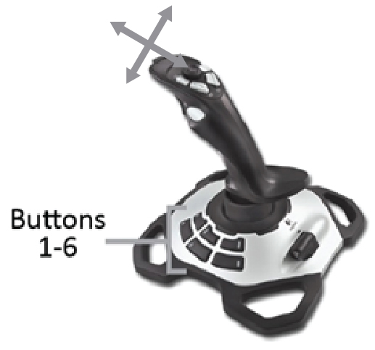Note 1: The press button 1 or 2-second long sip is reserved to be used for Xbox Adaptive Controller.

# Setting Up the LipSync Gaming with the Xbox Adaptive Controller

1. Turn on your XBOX Console.
2. Turn on your Adaptive Controller by pressing the XBOX button Related image.
3. 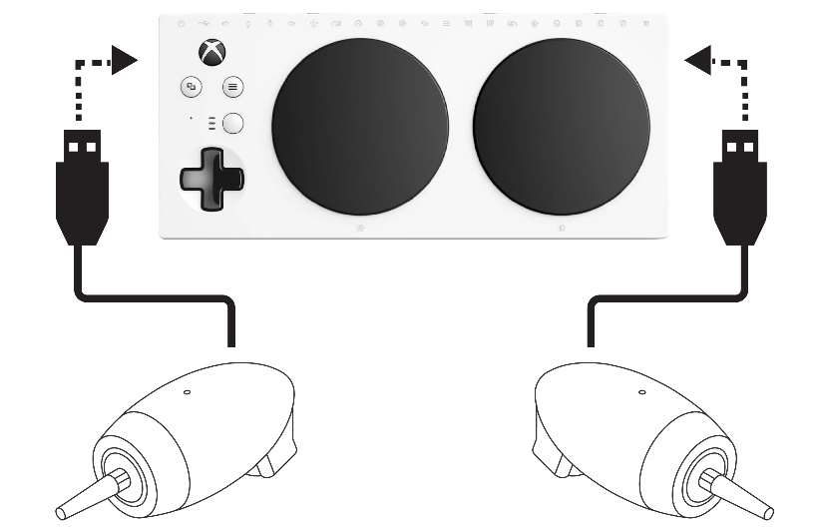Plug the LipSync USB Cable to the right or left USB port on either side of the Adaptive Controller. **Each side has different gaming functions** so double check with the user.

RIGHT USB PORT

LEFT USB PORT

1. Adjust the sensitivity of the sip-and-puff features by pressing the triangular buttons on the back of the LipSync. Increase the sensitivity by pressing the triangular button and decrease it by pressing the triangular button.



1. If any of the functions starts to drift while you’re playing a game, release the mouthpiece and hold both triangular buttons at the same time to reset.

## Functions (Xbox Adaptive Controller):

The following functions are the default options for the specified actions which can be modified using profile settings.

|  |  |  |  |
| --- | --- | --- | --- |
| Action | Time (Seconds) | Function (Left USB port) | Function (Right USB port) |
| Mouthpiece (Right) | N/A | Move right | Move right |
| Mouthpiece (Down) | N/A | Move down | Move down |
| Mouthpiece (Left) | N/A | Move left | Move left |
| Mouthpiece (Up) | N/A | Move up | Move up |
| Puff | 1 | X1 | View |
| Sip | 1 | X2 | Menu |
| Puff | 2 | LS | RS |
| Sip | 2 | LB / Shift | RB |
| Puff | 3 | A | X |
| Sip | 3 | B | Y |

## Customize Profile

The Xbox Adaptive Controller comes with the option to configure and map buttons using 3 different mapping profiles. Switch between profiles by pressing on the Profile Button or pressing the ***Shift*** button after it’s assigned in settings. **[2]**

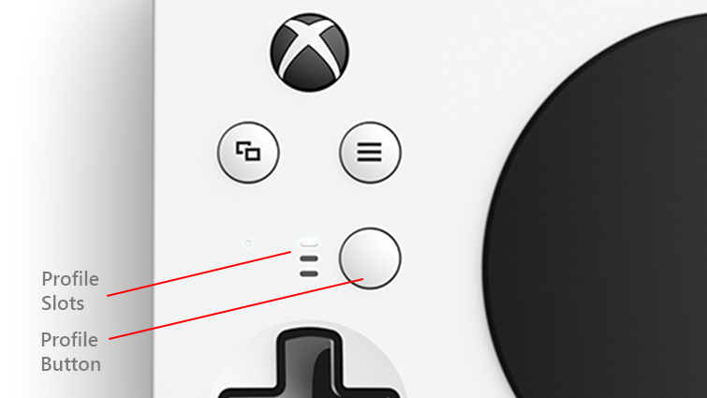

Please follow the instructions below to map the buttons through the ***Profile*** settings:

1. Press the ***Xbox*** button to open the guide.
2. Select Home > Settings > Kinect and Devices > Devices & Accessories.
3. Press the ***A*** button (3 second puff) > Select ***Xbox Adaptive Controller***.
4. Select ***Configure*** option > press the ***A*** button (1 second puff).
5. Select ***New profile*** > press the ***A*** button (3 second puff).
6. Enter the name for the new profile (Example: “***LipSync1***”).
7. Under the ***Mapping*** menu, select the Xbox controller button that you would like to map >pressthe ***A*** button (3 second puff).
8. Assign the ***Primary*** and ***Shift*** button actions for selected button > press the ***B*** button (3 second sip).
9. The following five examples can be used to map the main buttons:
   * ***X1*** button or short puff
     1. Under the ***Mapping*** menu, select the ***X1*** button > pressthe ***A*** button (3 second puff).
     2. Assign the ***Primary*** and the ***Shift*** button actions for selected ***X1*** button.
     3. The ***Primary*** button action is assigned to the ***A*** button and the ***Shift*** button action is assigned to the ***X*** button for the ***X1*** button in the ***LipSync1*** profileexample.
     4. Press the ***B*** button (3 second sip).
   * ***X2*** button (1 second sip)
     1. Under the ***Mapping*** menu, select the ***X2*** button > pressthe ***A*** button (3 second puff).
     2. Assign the ***Primary*** and the ***Shift*** button actions for selected ***X2*** button.
     3. The ***Primary*** button action is assigned to the ***B*** button and the ***Shift*** button action is assigned to the ***Y*** button for the ***X2*** button in the ***LipSync1*** profileexample.
     4. Press the ***B*** button (3 second sip).
   * ***LS*** button or 2 seconds long puff
     1. Under the ***Mapping*** menu, select the ***LS*** button > pressthe ***A*** button (1 second puff).
     2. Assign the ***Primary*** and the ***Shift*** button actions for selected ***LS*** button.
     3. The ***Primary*** button action is assigned to the ***LS*** button and the ***Shift*** button action is assigned to the ***RS*** button for the ***LS*** button in the ***LipSync1*** profileexample.
     4. Press the ***B*** button (3 second sip).
   * ***A*** button or 3 seconds very long puff
     1. Under the ***Mapping*** menu, select the ***A*** button > pressthe ***A*** button (1 second puff).
     2. Assign the ***Primary*** and the ***Shift*** button actions for selected ***A*** button.
     3. The ***Primary*** button action is assigned to the ***View*** button and the ***Shift*** button action is assigned to the ***View*** button for the ***A*** button in the ***LipSync1*** profileexample.
     4. Press the ***B*** button (3 second sip).
   * ***B*** button or 3 seconds very long sip
     1. Under the ***Mapping*** menu, select the ***B*** button > pressthe ***A*** button (1 second puff).
     2. Assign the ***Primary*** and the ***Shift*** button actions for selected ***B*** button.
     3. The ***Primary*** button action is assigned to the ***Menu*** button and the ***Shift*** button action is assigned to the ***Menu*** button for the ***B*** button in the ***LipSync1*** profileexample.
     4. Press the ***B*** button (3 second sip).
10. Under the ***Mapping*** menu, select the button that you would like to map to the ***Shift*** button action > pressthe ***A*** button (1 second puff).
11. Select the ***Use as Shift*** button check box > press the ***A*** button (1 second puff) > press the ***B*** button (1 second sip).
12. Press the ***B*** button (1 second sip) to enter the ***Profiles*** page again.
13. Select the new created ***LipSync1*** profile > pressthe ***A*** button (1 second puff).
14. Save the new profile by selecting the ***No Slot*** dropdown menu >press ***the A*** button (1 second puff).
15. Select one of the three available slots > press the ***A*** button (1 second puff).
16. The ***LipSync1*** profile is now ready to use. Press the Profile button on the Xbox Adaptive Controller to switch between profiles and select ***LipSync1*** profile for these functions:

|  |  |  |  |
| --- | --- | --- | --- |
| Action | Time (Seconds) | Primary | Shift |
| Mouthpiece (Right) | N/A | Move right | Move right |
| Mouthpiece (Down) | N/A | Move down | Move down |
| Mouthpiece (Left) | N/A | Move left | Move left |
| Mouthpiece (Up) | N/A | Move up | Move up |
| Puff | 1 | A | X |
| Sip | 1 | B | Y |
| Puff | 2 | LS | RS |
| Sip | 2 | LB (Shift Button) | LB (Shift Button) |
| Puff | 3 | View | View |
| Sip | 3 | Menu | Menu |

# Cleaning the LipSync

The mouthpiece and filter are medical grade products used for capturing saliva. Each user should have their own set of mouthpiece and filter for hygienic reasons. It has a life cycle of 3-6 months depending on how often it’s used and how much saliva is trapped by the filter.

Unused pieces should be kept in a clean sealed bag away from the sun and used ones should be disposed of after each cycle.

The GamesStik casing is 3D printed layer by layer in plastic. Due to this, tiny gaps are formed between each layer, making the casing porous and not resistant to water.

Do:

* Wipe with a non-abrasive cloth lightly dampened with water
* Benzalkonium chloride antiseptic wipes can be used on mouthpiece
* Mouthpiece can be rinsed in cold water and air dried in its 3-6 month life cycle

Don’t:

* Avoid using abrasive cleaning materials
* Alcohol will destroy the plastic material
* Do not use any cleaning agents or soap
* Do not wash the filter

# References

1. [ArduinoJoystickLibrary Github repository](https://github.com/MHeironimus/ArduinoJoystickLibrary)
2. [Customize the Xbox Adaptive Controller in the Xbox Accessories app](https://support.xbox.com/en-US/xbox-one/controllers/customize-adaptive-controller-in-xbox-accessories-app)
3. [How do I use Shift with the Xbox Adaptive Controller?](https://support.xbox.com/en-CA/xbox-one/controllers/use-shift-with-adaptive-controller)